Swetha R

|  |  |
| --- | --- |
| Team ID | PNT2022TMID43211 |
| Project Name | Nutrition Assistant Application |

Environment Setup Docker Account Creation

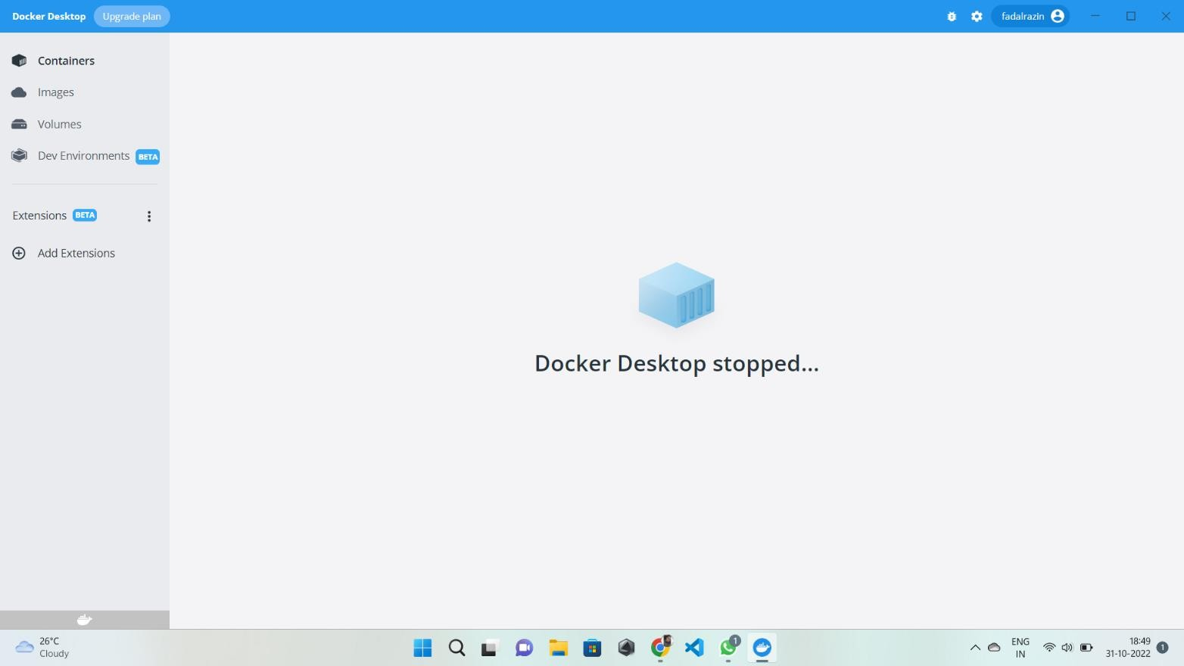

Swetha S

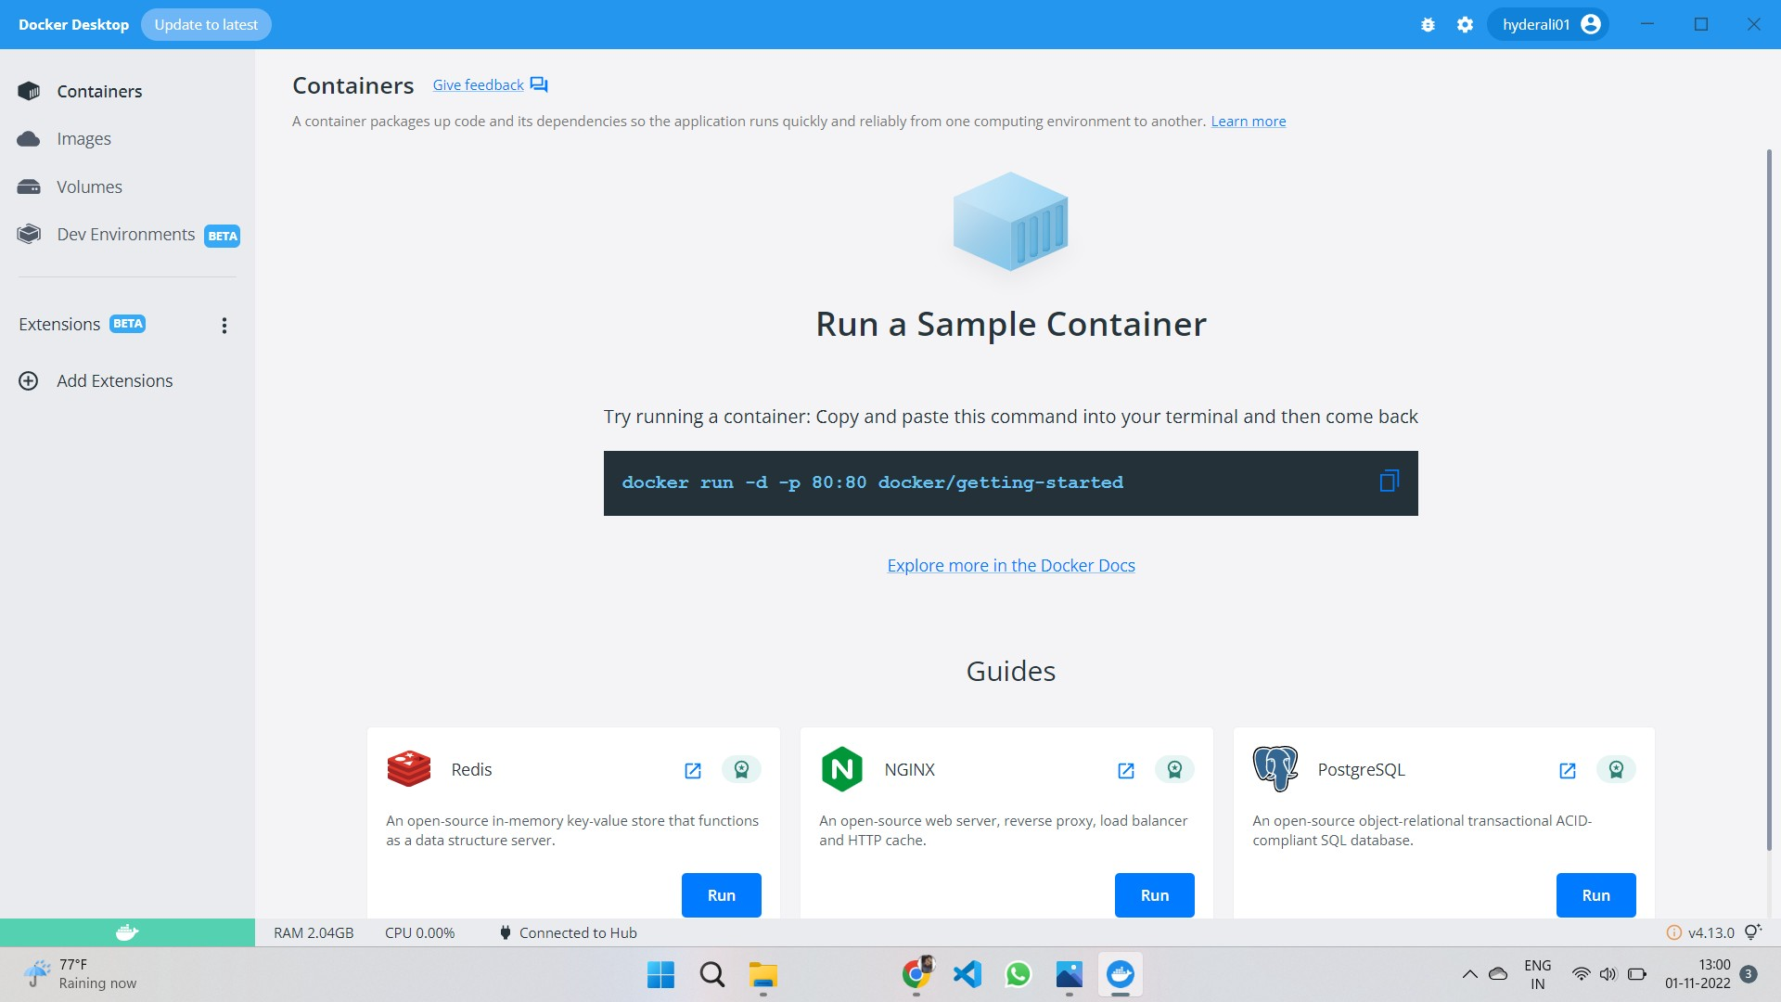

Susmitha S

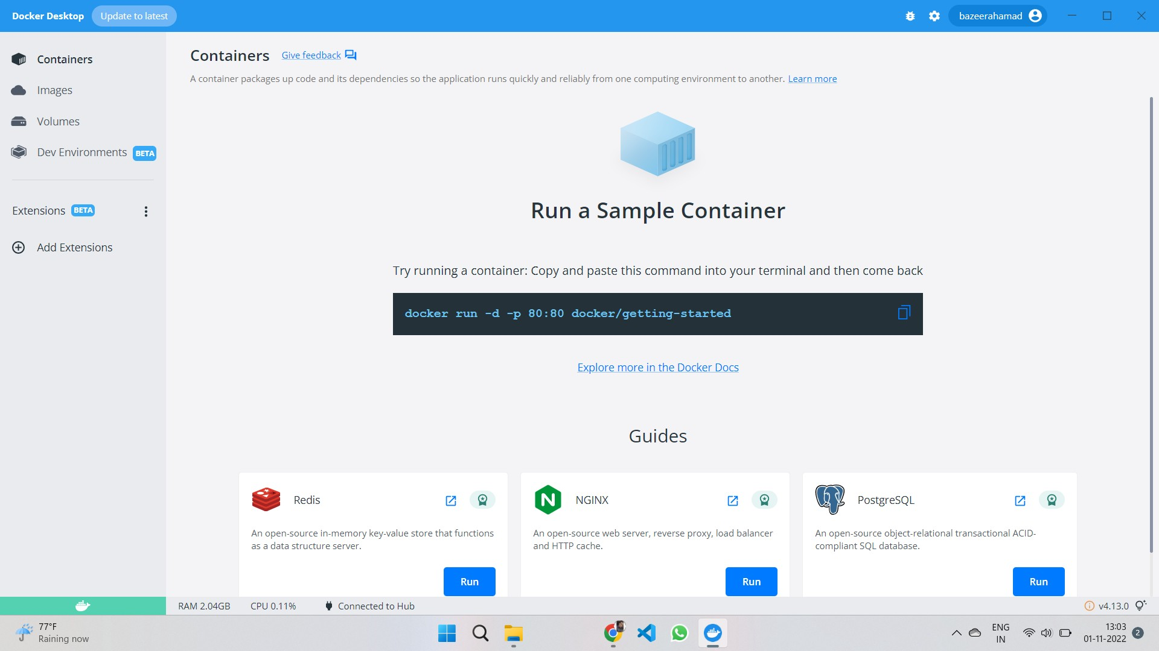

Snehalatha JB

